Summary and Reflections Report: Software Testing in the SDLC
CS 320: Software Test, Automation QA
12/14/2025

Summary of Unit Testing Approach
Testing Approach and Alignment to Requirements For Project One, I was tasked with developing three distinct components—the Contact Service, Task Service, and Appointment Service—to function as the backend for a mobile application. My unit testing approach was grounded in a Test-Driven Development (TDD) mindset, in which requirements served as the strict blueprint for both the object logic and the tests.
For each feature, I used JUnit 5 to verify functionality in isolation. My approach was to identify the "happy path" (valid inputs) and the "error path" (invalid inputs) for every requirement. For example, the requirements stated that a Contact ID "shall not be null and shall not be updatable." To align with this, I wrote specific test cases to attempt to create a contact with a null ID and verified that the application rejected the request. I then ensured that no setter method existed for the ID field, technically enforcing the "not updatable" requirement. This rigorous alignment ensured that every constraint specified in the prompt—such as the 10-character limit for IDs or the requirement that appointment dates be in the future—was explicitly implemented in a unit test.
Defense of Quality and Code Coverage
I can confidently defend the quality of the JUnit tests because they achieved code coverage of over 80% (specifically, 80.9%). In software engineering, high code coverage is a quantitative measure indicating that the majority of the codebase is executed during the test phase. This high percentage confirms that my tests did not merely check the easy scenarios; they also tested the exception-handling blocks. By achieving this level of coverage, I verified that the IllegalArgumentException checks in my constructors and setters were reachable and functioning, ensuring the application is robust against insufficient data.
Experience Writing JUnit Tests
Writing the JUnit tests required a balance of technical soundness and code efficiency.
- Technically Sound Code: To ensure the code was technically sound, I utilized JUnit’s assertThrows functionality. This allowed me to verify that the application fails gracefully when strict requirements are violated, rather than crashing or accepting invalid data. For example, in the ContactTest class, I used the following code to verify that a contact cannot have a phone number that is not precisely 10 digits:
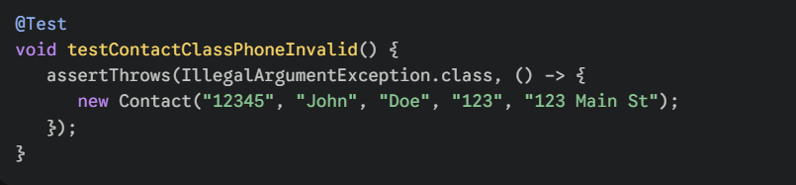
This snippet demonstrates technical soundness by showing that the application enforces the business rule (phone length) at the object level.
- Efficient Code: To ensure efficiency and maintainability, I utilized the @BeforeEach annotation to handle test setup. Instead of instantiating a new ContactService or TaskService inside every single test method—which would create repetitive, bloated code—I centralized this logic. This reduces memory overhead and makes the test suite easier to read.
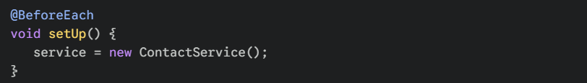
This approach ensures that every test starts in a clean state, without redundant code, thereby adhering to the "Don't Repeat Yourself" (DRY) principle.
Reflection
Testing Techniques: Throughout this project, the primary software testing technique was Unit Testing. This technique involves testing individual components of the software (classes and methods) in isolation from the rest of the system. A characteristic of unit testing is its granularity; it focuses on the smallest testable components of an application to ensure they function correctly before integration.
Within these unit tests, I employed Black-Box Testing techniques, specifically Boundary Value Analysis and Equivalence Partitioning.
- Boundary Value Analysis: This involves testing the extreme edges of input limits. For example, because the requirement specified that the description could not exceed 50 characters, I tested strings of exactly 50 characters (valid) and 51 characters (invalid).
- Equivalence Partitioning: This involves grouping inputs into valid and invalid classes. For the Appointment Service, I treated all "past dates" as a single invalid partition and all "future dates" as a single valid partition.

Practical Uses
These techniques are vital in Agile development environments where changes happen frequently. Unit tests provide a safety net (regression testing) that allows developers to refactor code without fear of breaking existing functionality.
Testing Techniques Not Employed
I did not employ Integration Testing or System Testing for this project.
- Integration Testing verifies that different modules or services work together correctly. Since the Contact, Task, and Appointment services operated independently with no shared database or cross-communication, there were no interfaces to test.
- System Testing validates the complete, integrated software product against requirements, often in a production-like environment. Because there was no User Interface (UI) and the "client" was hypothetical, a complete system test was not feasible.
Practical Uses: Integration testing is critical in microservices architectures, where one service (e.g., Payment) must verify that it can communicate with another (e.g., Inventory). System testing is the final gate before release, ensuring that the product meets users' business needs in a real-world scenario.
Mindset and Caution
Acting as a software tester requires an attitude of extreme caution and skepticism. It was essential to appreciate the code's complexity, particularly with respect to unique IDs. While the code for adding a task appears simple, the interrelationship between the TaskService list and the Task object is critical. If the service fails to check for a duplicate ID before adding a new object, data could be overwritten or corrupted.
- Example: I had to be cautious when writing the updateContact method. If I updated a field without first checking whether the ID existed, the application might throw a generic NullPointerException. By recognizing this complexity, I wrote a test case specifically for "Updating a non-existent ID" to ensure the service returned a clear, helpful error message rather than crashing.
Limiting Bias
One of the most challenging aspects was limiting bias. As the developer who wrote the code, I have a natural "confirmation bias"—I want my code to work, so I subconsciously tend to test only the "happy paths" (inputs I know will succeed). To mitigate this, I adopted a "destructive" mindset and actively attempted to break the application.
- Example: If I were testing my own code without checking bias, I might test the Appointment date with a date one year in the future. However, to limit bias, I forced myself to test a date that was just one millisecond in the past. This rigorous scrutiny is essential because, in real-world scenarios, a developer's bias can lead to "works on my machine" syndrome, in which critical bugs are missed. After all, the developer has not tested the specific edge cases that users will inevitably encounter.
Discipline and Technical Debt
Discipline in upholding quality standards is what distinguishes a professional engineer from a hobbyist. "Cutting corners", such as skipping a test case for a complex setter or ignoring a slightly low coverage score, inevitably leads to technical debt. Technical debt is the cost of additional rework incurred by choosing an easy solution now rather than adopting a better approach that would take longer.
- Plan to avoid technical debt: As a practitioner, I plan to treat test code as a "first-class citizen." This means applying the same coding standards, reviews, and refactoring to my tests as I do to my production code. By maintaining high test coverage and automating these tests in a Continuous Integration (CI) pipeline, I can ensure that technical debt is paid down immediately rather than accumulating interest that will eventually bankrupt the project's timeline.

References
Hambling, B., Morgan, P., Samaroo, A., Thompson, G., & Williams, P. (2019). Software Testing: An ISTQB-BCS Certified Tester Foundation Guide (4th ed.). BCS, The Chartered Institute for IT.
Grammarly. (2025). Grammarly [Computer software]. https://www.grammarly.com

